

PJT02513. R4C.SAP.FS.DLA.Customer_Enrollment.Switch_Indicator.CRM_ENH_DLA_004 | 



REVIEWER(S)
Name | Title | Department | Reviewed (date/time)
Manoj Ajgaonkar | SAP QA Advisor | SAP
Scott Tingle | AMI Program Lead | BTS
Jack Hobbick | Testing Program Manager | Business Integration Team
Amit Jadli | Testing Lead, Capgemini | Smart Energy Program
Jessica Scott | Audit Controls, Deloitte | Smart Energy Program
Clark Oeler | Audit Controls, Deloitte | Smart Energy Program
Chaitanya Kodela | Solution Architect | Smart Energy Program
Frank Lubis | CUST SUPPORT MGR | CE&O SCC-Lansing VCC

APPROVER(S)
Name | Title | Department | Approval (date/time)
Thomas Clark | DIV Program Mgr | Smart Energy Program
Elody Samuelson | DIV Program Mgr | Smart Energy Program
Zachary Pakkala | BUS SPRT CNSL II | Smart Energy Program
Loknath Sriparavastu | SAP lead, CMS Energy | Smart Energy Program
Ramesh Swarna | SAP Lead, Capgemini | Smart Energy Program
Tom Spring | BTS TECH | BTS SDM
Chad Conrad | BTS PROJECT MGR II | BTS SDM

CONTRIBUTORS
Name | Organization | Area of Contribution

VERSION HISTORY
Version | Date | Author(s) | Revision Notes
0.1 | 01/19/2015 | Abhishek Bansal | Initial version
0.2 | 02/16/2015 | Abhishek Bansal | Ready for Review/Approval
1.0 | 04/13/2015 | Ed Abranovich | Approved Baseline Work Product

Table of Contents

REVIEWER(S) 2
APPROVER(S) 2
1 OBJECT REQUIREMENT SUMMARY 4
1.1 Object Information and Attributes 4
1.2 Requirements Summary and Business Driver 5
1.3 Assumptions 6
1.4 Current Functionality 6
1.5 Required Functionality 6
1.6 Project / Development Constraints 8
1.7 Performance Criteria 8
1.8 Other Objects Affected 9
1.9 External References 9
1.10 Definitions/Acronyms/Abbreviations 9
2 ENHANCEMENT DESIGN SPECIFICATIONS 10
2.1 Detail Requirements - Enhancement 10
2.2 Custom Class 17
2.3 Standard Rule 17
2.4 Custom Table Creation 17
2.5 Work Item Delivery Requirements 17
2.6 Triggering Events Determination 17
2.7 Escalation Requirements 17
2.8 Dependencies 17
2.9 Error Handling Method 17
2.10 Post Execution Notification Details 17
2.11 Process Log Details 17
2.12 Other 18
2.13 Unit Test Plan 18
2.14 Information Security 18
2.15 Audit 18
2.16 Questions / Issues / Risks 18

OBJECT REQUIREMENT SUMMARY

Object Information and Attributes

The following is current information about this object and document:
Object ID | CRM_ENH_DLA_004
Title | PJT02513.CBR4C.FS.DLA.Customer_Enrollment.Switch_Indicator.CRM_ENH_DLA_004
Team Which Owns the Object | DLA SAP team
System Version | CRM 7.0
Development Type | Enhancement
Priority | High
Estimated Complexity | Medium
Link to Process Flow | Refer to System BPD for DLA Customer Enrollment: http://teams/sites/PMO%20Team/SGE/SGE%20Documents/Release%204%20Complex%20Billing/Release%20R4c/08%20Work%20In%20Progress/Define/System%20Business%20Process%20Design/DLA%20Switch/PJT02513%20R4c%20SAP%20SBPD%20DLA%20Customer%20Enrollment%20and%20Work%20Management.docx

Requirements Summary and Business Driver

The Direct Load Administration (DLA) program is to provide a method of demand-side grid load shedding by means of one or more on/off switches installed on the load side of a customer’s premise, between an air conditioning unit(s) and the AMI meter. These switches can then be remotely activated by Consumer’s to control A/C load shedding, as per the customer’s contractual agreement and the need for a particular grid load-shedding event.

Based on the contractual agreement to participate in a grid load-shedding event, the customer is rewarded with a discounted billing rate. The DLA specific billing rate is contingent to a customer’s active enrollment and participation in the the DLA program. Accordingly, upon completion of DLA Enrollment, the customer contract is switched to the discounted rate. Likewise, upon a DLA de-enrollment, for process triggers covered later, the customer contract is switched back to a standard rate.

The following gap from the DLA System Business Process document is addressed in this specification.
Ref. | PRICEFW ID | Enhancement Description
DDCE-087 | CRM_ENH_DLA_004 | Upon successful DLA enrollment, Business Data environment will display DLA indicators at two levels:  - Installation node to show DLA rate  - SAP Device Location node (Service Delivery Point) to show an “active” DLA switch icon.  Likewise, upon DLA de-enrollment, Business Data environment will change the DLA indicators at the two levels in accordance:  - Installation node to show non-DLA rate  - SAP Device Location node (Service Delivery Point) to show “inactive” DLA switch icon.

Alternatives to Object
The rate display at the Installation node is built into the existing solution. The CE CSRs will be need to infer DLA enrollment based on the presence of DLA rate. This will however, not enable the capability to see whether a Switch is on the property or not, irrespective of DLA program enrollment.

Impact of Implementation
By implementing the proposed changes, the CE CSRs will be better placed to route DLA calls to the DIV call center.

Impact of No Implementation

Incorrect routing of DLA calls that first come to the CE Call Centers.

Assumptions

Description:
- DIV communicates completed customer enrollments correctly.
- DIV communicates de-enrollments the same day of the event.
- The customer is informed via DIV or Consumers’ call centers, the merits of a DLA rate, and the de-merits of losing one.

Current Functionality

The CRM for Utilities solution by SAP Standard provides views, to represent CR&B data in indented tree structures, typically called “Data environments”. These structures graphically display the linked Business and Technical master data in a single view. Technical data consists of Connection Object, Premise, Installation, Device and Device Location. The Device here, relates to meters for Electric and Gas services. The Device does not relate to DLA switches.

Required Functionality

DLA Switch installation or removal should be visible in the SAP Data Environments. This requirement needs to be supported through the following scenarios:

Enrollment with Switch Install – Upon enrollment into the DLA program accompanied by the installation of DLA Switch, the SAP data environment used by the Call Center agents should display the DLA switch, for the related service point. The following mockup, displays the change in the Data environment, that depicts the presence of a switch, and an active DLA enrollment.
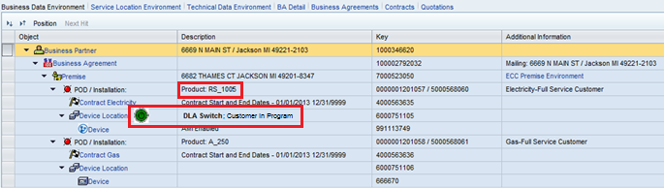

De-enrollment with Switch Removal - Upon de-enrollment from the DLA program, if the switch is removed too, the SAP data environment used by the Call Center agents should discontinue the display of the DLA switch, for the related service point. The following mockup, displays the change of state, such that the Rate is changed back to the non-DLA rate, and the Switch is not installed on the servie point anymore..

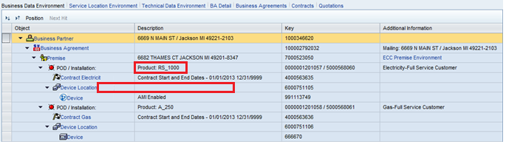

De-enrollment without Switch Removal – Upon de-enrollment from the DLA program, if the switch is not removed, the SAP data environment used by the Call Center agents should continue to display the DLA switch, for the related service point. However, this time the indicator should be differentiable to indicate that the Customer is de-enrolled or “Not in Program”.
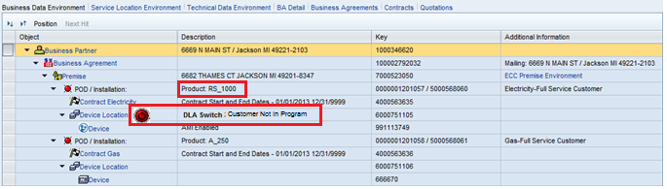

Enrollment without Switch Install – Upon enrollment into the DLA program not accompanied by the installation of DLA Switch, the SAP data environment used by the Call Center agents should display the DLA switch, for the related service point. The following mockup, displays the change in the Data environment, that shows the switch icon is reverted back to “Green”, hence an active DLA enrollment with the DLA rate.


As shown above, in different scenarios a data environment will display different information to the CE CSR. The mock-ups above do not show, a Location text, e.g. “Out rear”, that will appear ahead of “DLA Switch..” text, added as part of this enhancement.

Interaction Center Webclient, is accessed via multiple Business Roles, and the changes will be effective for all of the following roles:

Role Name | Role Description
ZCRM7_BRC | CSR III B. Role - BRC Switch
ZCRM7_PRM | CSR III B. Role - PRM Switch
ZCRM7_TEAM | CRM 7.0 Functional Team Role
ZIC_BCOP | Business Ctr Bus. Role (7)
ZIC_BKOF | Customer Billing Bus. Role (4)
ZIC_CSR1 | CSR I Business Role (1)
ZIC_CSR2 | CSR II Business Role (2)
ZIC_CSR3 | CSR III Business Role (3)
ZIC_CSRX | Outsource CSR Business Role-10
ZIC_EAM | EAM Business Role (6)
ZIC_TRAINING | Training Dept Bus. Role (0)
ZIC_VCC | VCC Mgmt Bus. Role (9)
ZIC_RVRC | Revenue Recovery Bus. Role (5)
ZIC_CLNT | Client Services Bus. Role (8)

Additionally, different data environments can be accessed via Customer Factsheet, Account Balance, Contract Management and so on. All of these views containing the SAP Data environments, will be updated consistently.

Project / Development Constraints
None Identified.

Performance Criteria

The introduction of a DLA Switch indicator in the SAP CRM Data environments, is not expected to impact the current system performance. It is however understood, that additional data related to the DLA Switch, will need to be processed, to support the proposed changes. The changes will be designed in a way, that no additional calls to the backend system are required as a result of this enhancement.

Other Objects Affected
None Identified.

External References
PJT02513 R4c SAP FS DLA WM Work Order Information Exchange

Definitions/Acronyms/Abbreviations

DIV | Device Installation Vendor
SAP | Systems, Applications & Products in Data Processing
DLA | Direct Load Adminstration
CRM | Customer Relationship Management SAP system
CE | Consumers Energy
CSR | Customer Service Representative
WO | Work Order
Service Delivery Point ID | SAP Device Location
DPP | Dynamic Peak Pricing
CSDD | Customer Select Due Date

ENHANCEMENT DESIGN SPECIFICATIONS

Detail Requirements - Enhancement

As covered in Section 1.5, the DLA switch indicator will be displayed on the data environments.
The following Navigation links (taken from the Business Role “CSR III Business Role (3)- ZIC_CSR3”) lead to CRM7 views that contain detailed Data environments.

- Customer Factsheet – The Data Environment at the bottom has three tabs, each of which has a Device level.

Business Data environment:
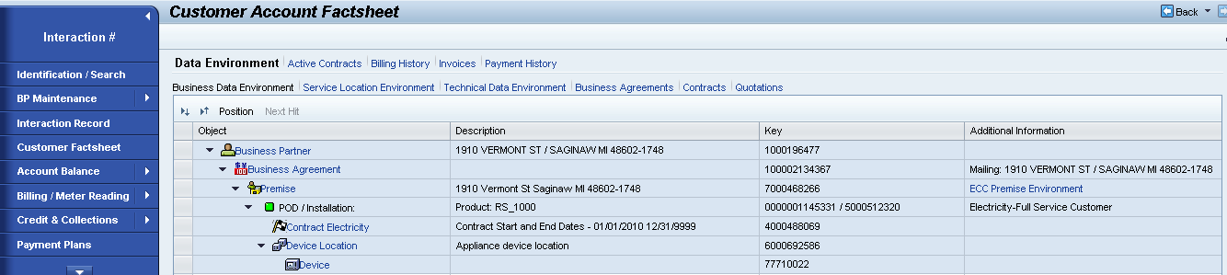

Service Location environment:
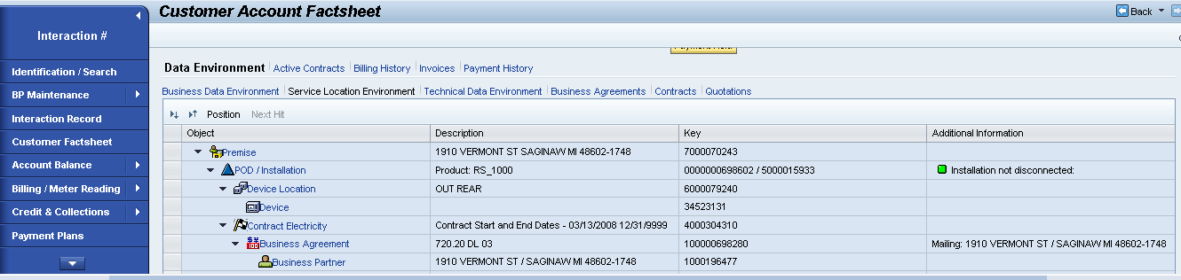

Technical Data environment:
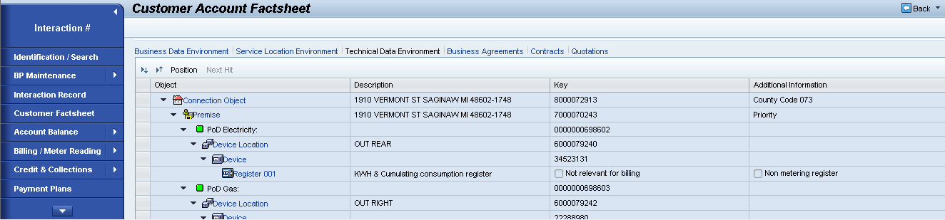

The three environments are using the following profiles, which need to be updated for the Device Location Node, as shown in the mockups unders Section 1.5:
Business Data – ZFS_BP
Service Location – ZFS_SL2
Technical Data – ZFS_TD

- Account Balance -> Data Environments
The data environments displayed below have the Business Data, Service Location and Technical Data environment available.
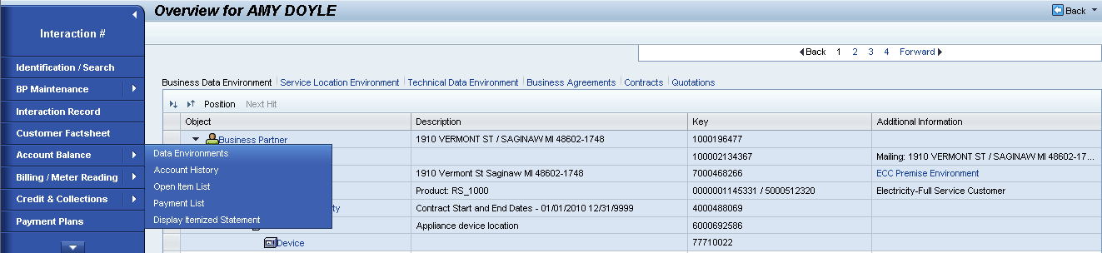
The three environments (similar to the one for Factsheet view) are using the same profiles, mentioned above, i.e.
Business Data – ZFS_BP
Service Location – ZFS_SL2
Technical Data – ZFS_TD

- Billing View: The Billing/Invoice data environment is available, as below:

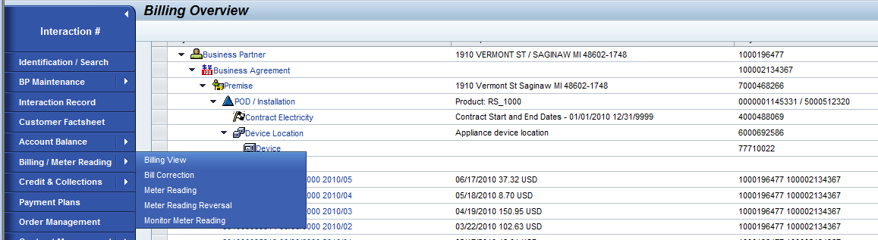
The data environment is set against the Tree Profile “ZMPB_BD”, and will need to be updated for the Device Location node. The DLA Switch text will be appended in the 2nd column.

- Contract Management views: The Service Environment is available for two of the views below

New Contracts:
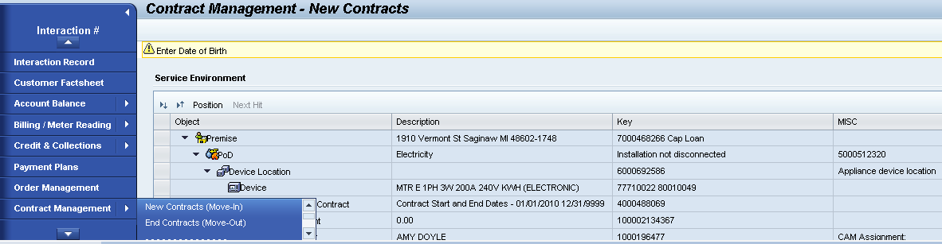
The data environment is set against the Tree Profile “ZPMI_SL2”, and will need to be updated for the Device Location node.

End Contracts:
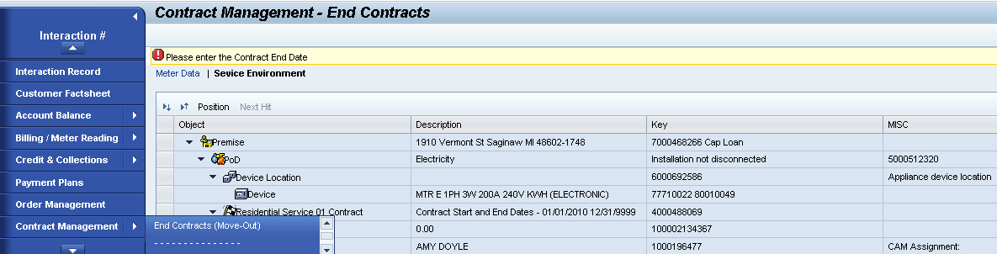
The same ZPMI_SL2 profile is used here.

- Order management: Two data environments are available within Order management work center.

Technical Data Environment:
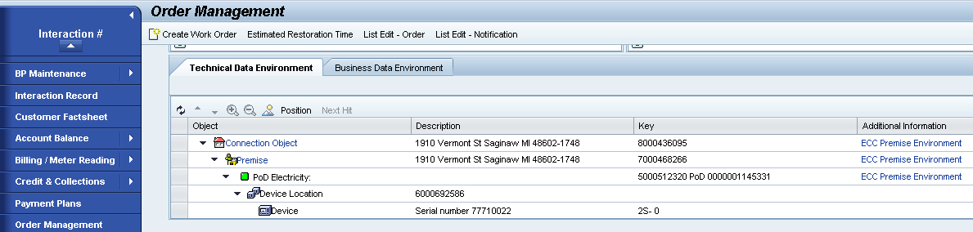
The data environment is set against the Tree Profile “ZSO_TMD”, and will need to be updated for the Device Location node.

Note: The text in Description and Key columns, will be shifted by 1 column each, to make it consistent with the other Data Environments. The shift will in turn make way for the DLA Switch text.

Business Data Environment:
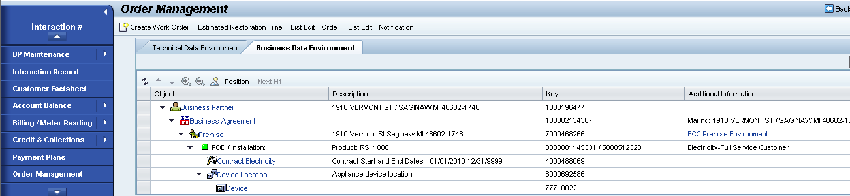
The data environment is set against the Tree Profile “ZFS_BP”, and will need to be updated for the Device Location node.

Note: The text in Description column, will be shifted to the “Additional information” column to make it consistent with the other Data Environments. The shift will in turn make way for the DLA Switch text.

Additionally, the Navigation link (taken from the Business Role “EAM Business Role (6)
- ZIC_EAM”) leads to CRM7 views containing detailed Data environments. The tree – Technical Data Environment, goes down another level, upto the Register level detail, as shown below.

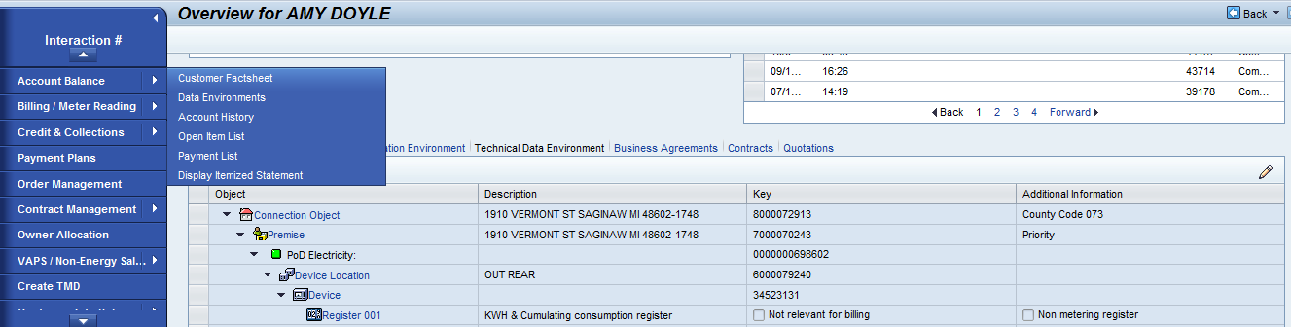
The data environment is set against the Tree Profile “ZEAM_TD”, and will need to be updated for the Device Location node.
Note: The text in Description column, will be shifted to the “Additional information” column to make it consistent with the other Data Environments. The shift will in turn make way for the DLA Switch text.

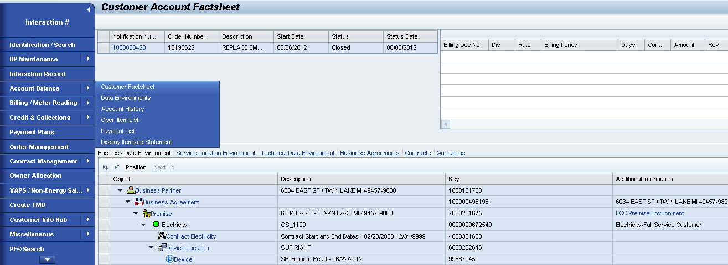
The data environment is set against the Tree Profile “ZIUIC_SL2”, and will need to be updated for the Device Location node.
Note: The text in Description column, will be shifted to the “Additional information” column to make it consistent with the other Data Environments. The shift will in turn make way for the DLA Switch text.

Another Navigation link (taken from the Business Role “Business Ctr. Bus. Role (7)
- ZIC_BCOP”) leads to CRM7 Contract details view containing detailed Data environments. The tree – Device Data Environment, will be impacted as shown below.

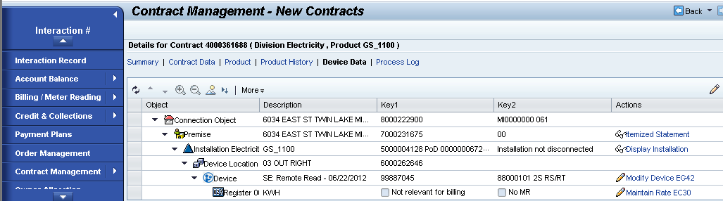
The data environment is set against the Tree Profile “ZIUIC_TD2”, and will need to be updated for the Device Location node.
Note: The text in Description column, will be shifted to the “Key2” column to make it consistent with the other Data Environments. The shift will in turn make way for the DLA Switch text.

Another Navigation link (taken from the Business Role “Customer. Billing Bus. Role (4)
- ZIC_BKOF”) leads to CRM7 Contract details view containing detailed Data environments. The tree – Device Data Environment, will be impacted as shown below.


The data environment is set against the Tree Profile “ZIUIC_TD”, and will need to be updated for the Device Location node.
Note: The text in Description column, will be shifted to the “Key2” column to make it consistent with the other Data Environments. The shift will in turn make way for the DLA Switch text.

Enhancement Requirements
Number | Description of Requirement
1 | Update the following RFC structures, to transfer the Switch Indicator (IFLOT- ZSWTHCNT) on Device Location to CRM:  CRM_ISU_DEVLOC_ATTR (enhance CI_FLOT)  EISU_IL_MD_DEVLOC (auto-updated when CI_IFLOT is extended).  Once these structures are consistently mapped, IsuDeviceLocation entity is updated via the abstract IF_CRM_IU_IL_ABSTR_NROOT~READ_ATTR method. Create Z-class ZCL_CRM_ISU_IL_MD_DEVICELOC to re-implement the method if required.  Note: If updating the IFLOT includes is to be avoided, an explicit (additional) RFC call will need to be made to ECC, that can have an adverse performance impact.
2 | Add MIME repository with the new icon files, on the below path:  /sap/public/bc/icons/icon_SwitchEnabled  /sap/public/bc/icons/icon_SwitchDisabled
3 | Touch the following classes:  ZCL_CRM_IU_BT_TD_ENH  ZZCL_CRM_IU_BT_TD_ENH  ZCL_CRM_DEVICETREE  ZCL_CRM_IU_BT_SL2_ENH  Update interface method GET_ATTRIBUTE to display the COL_2_IMG and COL_2 text.  The rules are:  - If IsuInstallation. TTYPTEXT = RS_1005 and IsuDeviceLocation. ZSWTHCNT NE NULL:  COL_2_IMG = /sap/public/bc/icons/icon_SwitchEnabled  COL_2 = “DLA Switch; Customer in Program”  - If IsuInstallation. TTYPTEXT NE RS_1000 and IsuDeviceLocation. ZSWTHCNT NE NULL  COL_2_IMG = /sap/public/bc/icons/icon_SwitchDisabled  COL_2 = “DLA Switch; Customer Not in Program”  - If IsuInstallation. TTYPTEXT NE RS_1000 and IsuDeviceLocation. ZSWTHCNT EQ NULL  COL_2_IMG = ‘’  COL_2 = ‘’

Description: Describe each activity mentioned in the process flow diagram.
Detailed Description of Activities
Activity 1 –

Activity 2 –

Activity 3 –

Custom Class
ZCL_CRM_IU_BT_TD_ENH
ZZCL_CRM_IU_BT_TD_ENH
ZCL_CRM_DEVICETREE
ZCL_CRM_IU_BT_SL2_ENH

Standard Rule
None Identified.

Custom Table Creation
None Identified.

Work Item Delivery Requirements
None Identified.

Triggering Events Determination
Inbound DLA Enrollment interface.

Escalation Requirements
None Identified.

Dependencies
Work Management and Customer Enrollment inbound Interface from DIV, delivered with functional specification, “PJT02513 R4c SAP FS DLA WM Work Order Information Exchange”.

Error Handling Method
None Identified.

Post Execution Notification Details
None Identified.

Process Log Details
None Identified.

Other
None Identified.

Unit Test Plan

The following scenarios need to be tested.
Unit test Step No | Test Condition | Expected Result | Actual Result
1 | Customer enrolled in DLA, switch installed. | Green switch icon displayed. Text says “DLA Switch; Customer in Program”.
2 | Customer de-enrolled from DLA, switch still installed. | Red switch icon displayed. Text says “DLA Switch; Customer Not in Program”.
3 | Customer de-enrolled in DLA, switch removed. | No switch icon displayed. No text displayed.
4 | New customer at Premise, with DLA switch installed | Red switch icon displayed. Text says “DLA Switch; Customer Not in Program”.
5 | Test Step 1, 2 and 3 for the Business roles and Navigation covered in section 2.1 | The results should remain consistent as for Steps 1, 2 and 3.
6 | Customer Enrollment Pending | No switch icon displayed. No text displayed.

Information Security
None Identified.

Information Classification
None Identified.

Security Roles (Profiles and Authorizations)
None Identified.

Table Security (if applicable)
None Identified.

ABAP Program Security (if applicable)
None Identified.

Audit
None Identified.

Questions / Issues / Risks
None Identified.

